National Education Policy 2020
Review by Atul Raj

NEP 2020 Contains 4 parts namely:
- School Education
- Higher Education
- Other Key Area of Focus
- Making It Happen

Introduction:
India will have the highest population of young people in the world over the next decade. It is very important to teach skill to all these people.

A good education institution is one in which every student feels welcomed and cared for, safe and stimulating learning environment exists, where a wide range of learning experiences are offered.
Here the Introduction section talks about, how AI will be a big thing and most of the jobs will be replaced by it. So we need an Education system which educates students about the new skills to be learned.

Part 1 – School Education
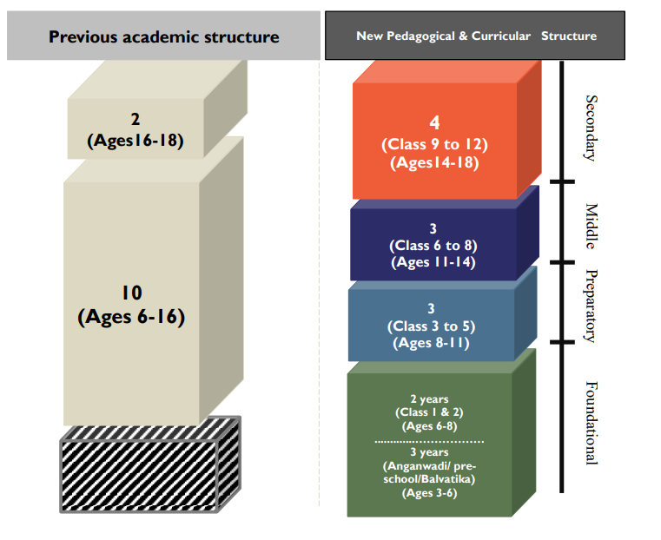
The new NEP brings in a new structure of 5 + 3 + 3 + 4

What is a skill?

Skill - noun
: the ability to use one's knowledge effectively and readily in execution or performance
: dexterity or coordination especially in the execution of learned physical tasks
: a learned power of doing something competently : a developed aptitude or ability

Personal Experience

Yoga
I remember I really like doing Yoga in school, this was in primary school(1 – 5). To this day Yoga has stayed with me. I also remember the encouragement that I get after doing Yoga I made me do it more.

Electronics
I was also interested in technical electric things, used to tear apart toys, try to fix them. In school when I first got introduced to computer, I was curious about it. I also remember the appreciation I got in school for my technical knowledge. I just plugged the CD player to TV. To this day I still tinker with electronics, now I can programmatically control them.
I remember childhood being great to explore things.

I think if there was a platform where I could learn skills, I would definitely do that. Skills or activities like Yoga / Electronics I would learn a lot and a lot quicker.

So, what are we doing again?
We are developing a platform where students of age 8 – 11 can learn skills that they already have but are not aware of it. I personally believe we a skilled already we just have to polish ourselves.
So this platform will provide Activities based on different skills.
As kids go to school they already have a lot of things to study, we want those things to be fun to study.
We want to create a fun and enjoyable environment for kids to learns the skill that they need. By using our platform they will sure ace their exams because we are building their skills and further explore the possibilities they could achieve.

Diagram of Skills and activity.
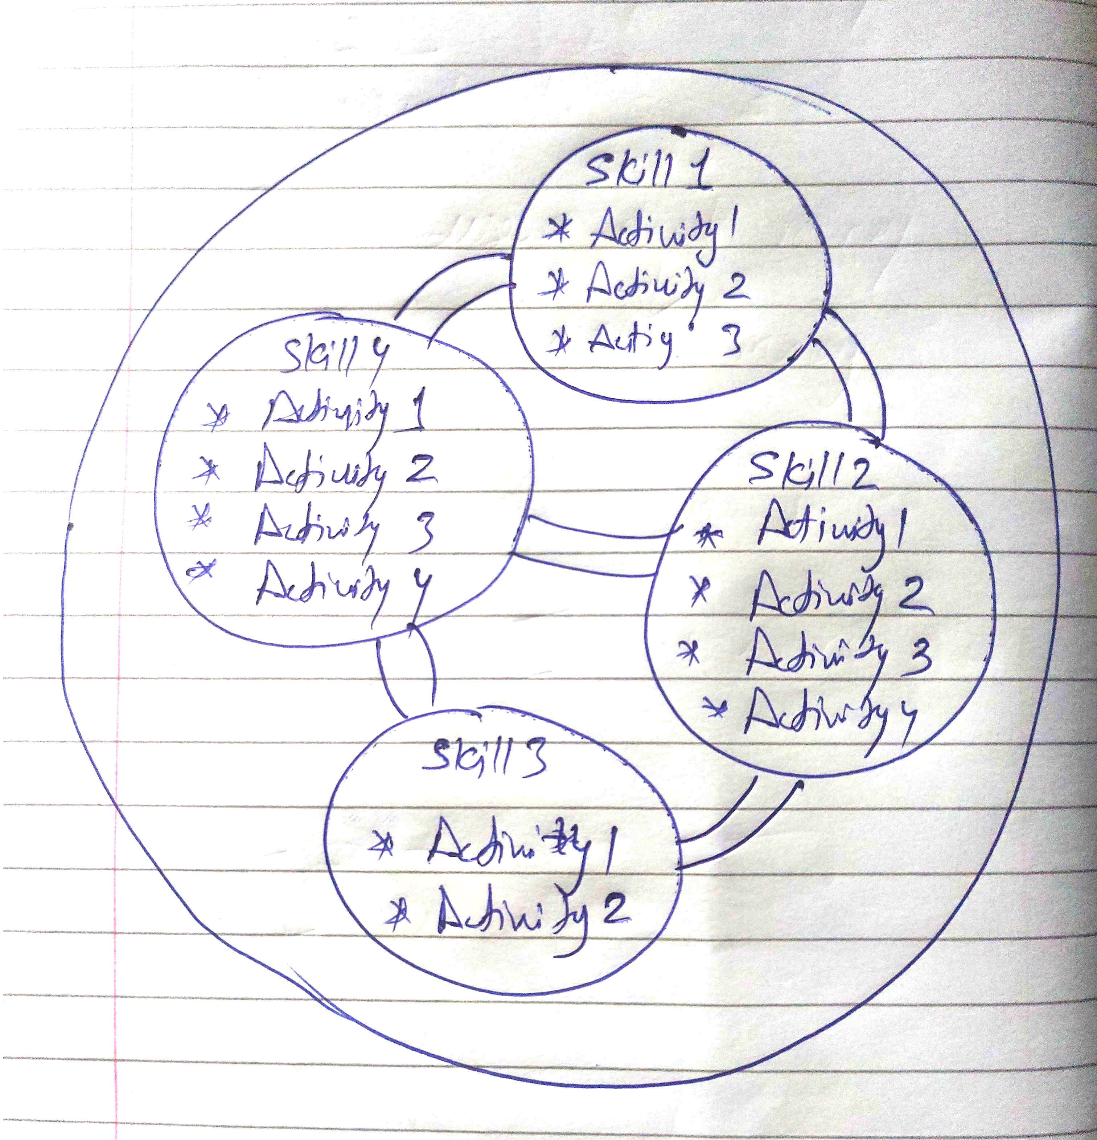

Imagine a 8 year old boy.
I got this basic age and Class table from the internet.

CBSE Age Limit for General Category
- Pre- Nursery: 2-3 years (born between 1 April 2019 and 31 March 2020)
- Nursery: 3-4 years (born between 1 April 2018 and 31 March 2019)
- KG: 4-5 years (born between 1 April 2017 and 31 March 2018)
- Class 1: 5-6 years (born between 1 April 2016 and 31 March 2017)
- Class 2: 6-7 years (born between 1 April 2015 and 31 March 2016)
- Class 3: 7-8 years (born between 1 April 2014 and 31 March 2015)
- Class 4: 8-9 years (born between 1 April 2013 and 31 March 2014)
- Class 5: 9-10 years (born between 1 April 2012 and 31 March 2013)
- Class 6: 10-11 years (born between 1 April 2011 and 31 March 2012)
- Class 7: 11-12 years (born between 1 April 2010 and 31 March 2011)
- Class 8: 12-13 years (born between 1 April 2009 and 31 March 2010)
- Class 9: 13-14 years (born between 1 April 2008 and 31 March 2009)
- Class 10: 14-15 years (born between 1 April 2007 and 31 March 2008)
- Class 11: 15-16 years (born between 1 April 2006 and 31 March 2007)
- Class 12: 16-17 years (born between 1 April 2005 and 31 March 2006)

According to this data. 8 year old boy can be in class 3 or 4. Suppose he is in class 3.

What does school teaches to 3rd graders in India?
Complete syllabus. https://www.safalta.com/school/ncert-syllabus-for-class-3

https://www.khanacademy.org/math/in-in-class-3rd-math-cbse
This is what I got Mathematics for Class 3.

Subjects of 3rd grader:
- Mathematics
- Environmental Studies
- English
- Hindi

NCERT Syllabus for Class 3 Maths
There are 14 chapters included in Classs 3 Maths Syllabus. The details are given as follows-
- Chapter 1: Where to Look From
- Chapter 2: Fun With Numbers
- Chapter 3: Give and Take
- Chapter 4: Long and Short
- Chapter 5: Shapes and Designs
- Chapter 6: Fun With Give and Take
- Chapter 7: Time Goes On
- Chapter 8: Who is Heavier?
- Chapter 9: How Many Times?
- Chapter 10: Play With Patterns
- Chapter 11: Jugs and Mugs
- Chapter 12: Can We Share?
- Chapter 13: Smart Charts!
- Chapter 14: Rupees and Paise

Website where all chapters are available digitally.
https://ncert.nic.in/textbook.php?cemh1=1-14

NCERT Syllabus for Class 3 EVS
There are 24 chapters in Class 3 EVS Syllabus. Let's have a look at them-
- Chapter 1. Poonam’s Day out
- Chapter 2. The Plant Fairy
- Chapter 3. Water O’ Water!
- Chapter 4. Our First School
- Chapter 5. Chhotu’s House
- Chapter 6. Foods We Eat
- Chapter 7. Saying without Speaking
- Chapter 8. Flying High
- Chapter 9. It’s Raining
- Chapter 10. What is Cooking
- Chapter 11. From Here to There
- Chapter 12. Work We Do
- Chapter 13. Sharing Our Feelings
- Chapter 14. The Story of Food
- Chapter 15. Making Pots
- Chapter 16. Games We Play
- Chapter 17. Here comes a Letter
- Chapter 18. A House Like This
- Chapter 19. Our Friends – Animals
- Chapter 20. Drop by Drop
- Chapter 21. Families can be Different
- Chapter 22. Left-Right
- Chapter 23. A Beautiful Cloth
- Chapter 24. Web of Life

NCERT Syllabus for Class 3 English
English Literature Syllabus for Class 3 English consists of 10 units, which are further divided into chapters. The chapter details are as follows-
Unit 1:
- Good Morning
- The Magic Garden
Unit 2:
- Bird Talk
- Nina and the Baby Sparrows
Unit 3:
- Little by Little
- The Enormous Turnip
Unit 4:
- Sea Song
- A Little Fish Story
Unit 5:
- The Balloon Man
- The Yellow Butterfly
Unit 6:
- Trains
- The Story of the Road
Unit 7:
- Puppy and I
- Little Tiger, Big Tiger
Unit 8:
- What’s in the Mailbox?
- My Silly Sister
Unit 9:
- Don’t Tell
- He is My Brother
Unit 10:
- How Creatures Move
- The Ship of the Desert
Grammar Syllabus incldes-
- Prepositions
- Nouns
- Verbs
- Tenses
- Adjectives
- Pronouns
- Conjunctions
- Adverbs
- Punctuations
- Antonyms & Synonyms
- Vowels & Consonants
- Animal sounds
- Syllables
- People and their work
- Family relation vocabulary

NCERT Syllabus for Class 3 Hindi
Class 3 Hindi syllabus includes literature and grammar section. The syllabus for Hindi Literature Rimjhim is as follows-
- पाठ 1: कक्कू
- पाठ 2: शेखीबाज़ मक्खी
- पाठ 3: चाँद वाली अम्मा
- पाठ 4: मन करता है
- पाठ 5: बहादुर बित्तो
- पाठ 6: हमसे सब कहते
- पाठ 7: टिपतिपवा
- पाठ 8: बंदर बाँट
- पाठ 9: कब आऊ
- पाठ 10: क्योंजीमल और कैसे कैसलिया
- पाठ 11: मीरा बहन और बाघ
- पाठ 12: जब मुझे साँप ने काटा
- पाठ 13: मिर्च का मजा
- पाठ 14: सबसे अच्छा पेड़
Hindi Grammar Syllabus is mentioned below-
- विलोम शब्द
- लिंग
- पर्यायवाची शब्द
- अनेक शब्दों के लिए एक शब्द

Adi: 4 class
Maths, English, Hindi, EVS, Computer, General Knowledge,
Pandemic caused issue to study, online classes does not help. Lack of teachers too.
Mother: Existed to see the application.

Aashi: 8 class
Subject: Hindi, English, Science, Computer, General Knowledge, Maths, SST(Social studies): (History, Civics, Geography)
Favorite subject: History
Why History? Learning about past.
School activities: Not much.
Phone usage: Listen to music.
Computer lab: C++
Missing elements: Not enough creative activities.

